URGENT CALL TO PRAYER! WILL YOU DO IT FOR THE CHILDREN
February 23rd, 2021

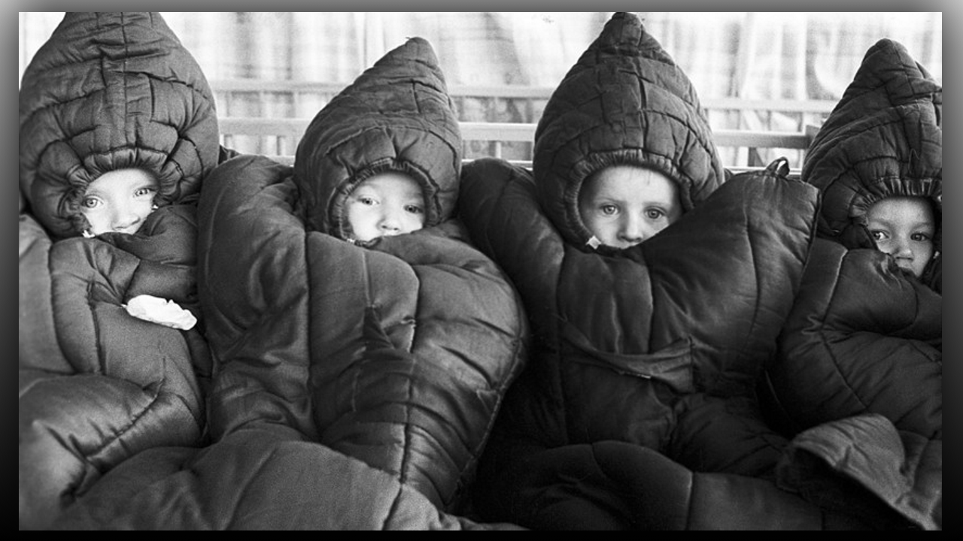
My Dear Heartdwellers, this is an URGENT call to prayer! Father Ezekiel was shown by the Lord what appeared to be film footage of very young children being released on the streets in sub-zero temperatures, barely clothed. He saw a small boy in a red jumper with only one sock on his foot, in freezing cold weather.

The Lord also showed Ezekiel, what appeared to be a woman, almost running a triage, driving around picking up several children in icy, wintry weather conditions.

There was a bus driver who spotted a small toddler about 18 months old with barely any clothing on in the midst of an icy, chilly cold. The toddler was on the street, all alone with people walking by just minding their own business and not helping the child. The bus driver suddenly stopped the bus and crossed over several lanes of traffic to pick up the toddler and brought the child into the bus and was immediately covered with coats to provide warmth.

Father Ezekiel saw another small child outside of a Denny’s restaurant and nobody was helping the child as they sat inside the warm building eating and being served food! It is our understanding that these children are being released from underground tunnels and captivity, so those who kidnapped the children in the first place, are trying to escape persecution for their crimes.

A few years ago, Father Ezekiel was asked by the Lord, if he would offer himself up as a victim soul. Jesus said to him, “Will you do it for the children?” Every year, Father renews this commitment.

Beloved Heartdwellers, please join us in praying for and offering up our sufferings for these young children. For the Lord to have great mercy on these innocent, precious ones that are so dear to Him.

May the Lord bless you abundantly and give you His peace.

